**HOME AUTOMATION**

**A Minor Project Report**

Submitted To



**Chhattisgarh Swami Vivekanand Technical University**

**Bhilai, India**

For

The Award of Degree

of

**Bachelor of Technology**

*in*

**Computer Science & Engineering**

*By*

| **ABBAS SHAKIR**  **Roll No.-30332218040**  **En. No. – BF4732**  **Semester 7th (CSE)** | **SIDDHARTH SINHA**  **Roll N0.-303302218038**  **En. No. – BF4730**  **Semester 7th (CSE)** | **POORVI SINGH THAKUR**  **Roll N0.-303302218033**  **En. No. – BF4725**  **Semester 7th (CSE)** |
| --- | --- | --- |

Under the Guidance of

**Mr.Deepak Rao Khadatkar**

Asst. Professor of Computer Science & Engineering

S.S.I.P.M.T, Raipur

**__________________________________________________________**



**Department of Computer Science & Engineering**

**Shri Shankaracharya Institute of Professional Management & Technology**

**Raipur (C.G.)**

**_________________________________________________________**

**Session: 2021 - 2022**

**DECLARATION BY THE CANDIDATE**

We the undersigned solemnly declare that the Minor project report entitled **“*HOME AUTOMATION*”** is based our own work carried out during the course of our study under the supervision of **Mr. Deepak Rao Khadatkar.**

We assert that the statements made and conclusions drawn are an outcome of the project work. We further declare that to the best of our knowledge and belief that the report does not contain any part of any work which has been submitted for the award of any other degree/diploma/certificate in this University/Deemed university of India or any other country.

| **ABBAS SHAKIR**  **Roll No.-30332218040**  **En. No. – BF4732**  **Semester 7th (CSE)** | **SIDDHARTH SINHA**  **Roll N0.-303302218038**  **En. No. – BF4730**  **Semester 7th (CSE)** | **POORVI SINGH THAKUR**  **Roll N0.-303302218033**  **En. No. – BF4725**  **Semester 7th (CSE)** |
| --- | --- | --- |

I

**CERTIFICATE BY THE SUPERVISOR**

This is to certify that the Minor project report entitled **“*HOME AUTOMATION*”** is a record of project work carried out under my guidance and supervision for the fulfillment of the award of degree of Bachelor of Engineering in the faculty of Computer Science & Engineering of Chhattisgarh Swami Vivekanand Technical University, Bhilai (C.G.) India.

To the best of my knowledge and belief the report

1. Embodies the work of the candidate himself
2. Has duly been completed
3. Fulfills the partial requirement of the ordinance relating to the B.E. degree of the University
4. Is up to the desired standard both in respect of contents and language for being referred to the examiners.

__________________________

(Signature of the Supervisor)

**Mr. DEEPAK RAO KHADATKAR**

Asst.Professor, Dept of C.S.E.

S.S.I.P.M.T, Raipur (C.G.)

Forwarded to Chhattisgarh Swami Vivekanand Technical University

Bhilai

_______________________________

(Signature of HOD)

**Dr. J P Patra**

HOD CSE S.S.I.P.M.T

Raipur, C.G

_______________________________

(Signature of the Principal)

**Dr. Alok Kumar Jain**

Principal S.S.I.P.M.T

Raipur, C.G

II

**CERTIFICATE BY THE EXAMINERS**

The project report entitled **“*HOME AUTOMATION*** “has been examined by the undersigned as a part of the examination of Bachelor of Engineering in the faculty of Computer Science & Engineering of Chhattisgarh Swami Vivekanand Technical University, Bhilai.

__________________ __________________

**Internal Examiner External Examiner**

**Date: Date:**

III

**Acknowledgement**

Working for this project has been a great experience for us. There were moments of anxiety, when we could not solve a problem for the several days. But we have enjoyed every bit of process and are thankful to all people associated with us during this period we convey our sincere thanks to our project guide **Mr. Deepak Rao Khadatkar** for providing us all sorts of facilities. His support and guidance helped us to carry out the project. We owe a great dept. of his gratitude for his constant advice, support, cooperation & encouragement throughout the project we would also like to express our deep gratitude to respected **Dr. J P Patra** (Head of Department) for his ever helping and support. We also pay special thanks for his helpful solution and comments enriched by his experience, which improved our ideas for betterment of the project. We would also like to express our deep gratitude to respected **Dr. Alok Kumar Jain** (Principal) and college management for providing an educational ambience. It will be our pleasure to acknowledge, utmost cooperation and valuable suggestions from time to time given by our staff members of our department, to whom we owe our entire computer knowledge and also we would like to thank all those persons who have directly or indirectly helped us by providing books and computer peripherals and other necessary amenities which helped us in the development of this project which would otherwise have not been possible.

| **ABBAS SHAKIR**  **Roll No.-30332218040**  **En. No. – BF4732**  **Semester 7th (CSE)** | **SIDDHARTH SINHA**  **Roll N0.-303302218038**  **En. No. – BF4730**  **Semester 7th (CSE)** | **POORVI SINGH THAKUR**  **Roll N0.-303302218033**  **En. No. – BF4725**  **Semester 7th (CSE)** |
| --- | --- | --- |

IV

**Table of Figures**

Figure 1 iot connectivity 2

Figure 2 blynk app interface 4

Figure 3 work flow of system 8

Figure 4 flow chart of system 10

Figure 5 installing nodemcu code in arduino ide 11

Figure 6 arduino ui with code 12

Figure 7 nodemcu esp8266 15

Figure 8 nodemcu pin configuration 16

Figure 9 relay module 19

Figure 10 different types of breadbord 21

Figure 11 jump wire 22

Figure 12 arduino ide 24

Figure 13 blynk app official picture 26

Figure 14 snapshot of blynk interface of our project 28

Figure 15 light is turned off when switch is off 29

Figure 16 light is turned on when switch is on 29

V

**Table of Contents**

CHAPTER 1 1

INTRODUCTION 1

1.1 WHAT IS IOT? 2

How does IoT work? 3

1.2 What is blynk? 4

1.3 OVERVIEW 5

1.4 How does an IoT based Home Automation System Work? 6

CHAPTER 2 7

MEATHODOLOGY 7

2.1 The Flow of the System 8

2.1.1 Flow chart of the system 10

2.2NodeMCU Code via Arduino IDE 11

CHAPTER 3 13

HARDWARE AND SOFTWARE REQUIREMENT 13

3.1 Hardware Requirement 14

3.1.1 NodeMCU 15

3.1.2 Pinconfiguration 16

3.1.3 Relay 19

3.1.4 Breadboard 20

3.1.5 There are different types of breadboards. 21

3.1.6 WiFi Module 22

3.1.7 Jump wire 22

3.2 Software requirement 23

3.2.1 Arduino IDE 24

3.2.2 Blynk App 25

CHAPTER 4 27

OUR PROJECT SNAPSHOTS 27

CAHPTER 5 30

RESULT AND DISCUSSION 30

5.1 Is a Smart Home Worth It? 31

5.2 Smart Home Products 31

5.3 Advantages 33

5.3.1 Save Energy with Smart Energy Consumption: 33

5.3.2 Customize as Per Your Convenience: 34

5.3.3 Ease of using smart home technology: 35

5.3.4 Smart home technologies are really Smart: 35

CHAPTER 6 37

CONCLUSION 37

CHAPTER 7 39

REFERENCES and BIBLIOGRAPHY 39

References 40

ABSTRACT

The internet of things (IoT) is connecting the devices and tools to the internet network to be controlled by websites and smartphone applications remotely, also, to control tools and instruments by codes and algorithms structures for artificial intelligence issues. In case we want to create advanced systems using python algorithms, Wi-Fi or Ethernet connection is connected to our tools, equipment, and devices controlling them by smart phone applications or internet websites. That’s actually the simplified definition of IoT. Farther than just using the IoT as a smart home to operate lamps or other home-use devices, it can be used as a security system or an industrial-use system, for example, to open or close the main building gate, to operate fully automatic industrial machines, or even to control internet and communication ports. And more ideas can be done by using IoT technology. A huge industrial facilities or governmental institution have much of lamps. Employees sometimes forget to turn them off at the end of the day. This research suggests a solution that can save energy by letting the security to control lighting of the building with his smart home by Blynk application. The lamps can be controlled by switches distributed in the building and Blynk application at the same time with a certain electrical installation. This research presents a simple prototype of smart home, or the easy way and low cost to control loads by Wi-Fi connection generally.

VI

CHAPTER 1

INTRODUCTION

1.1 WHAT IS IOT?

The internet of things, or IoT, is a system of interrelated computing devices, mechanical and digital machines, objects, animals or people that are provided with unique identifiers and the ability to transfer data over a network without requiring human-to-human or human-to-computer interaction.

A “thing” in the internet of things can be a person with a heart monitor implant, a farm animal with a biochip transponder, an automobile that has built-in sensor to alert the driver when tire pressure is low or any other natural or man-made object that can be assigned an Internet Protocol (IP) address and is able to transfer data over a network[1].

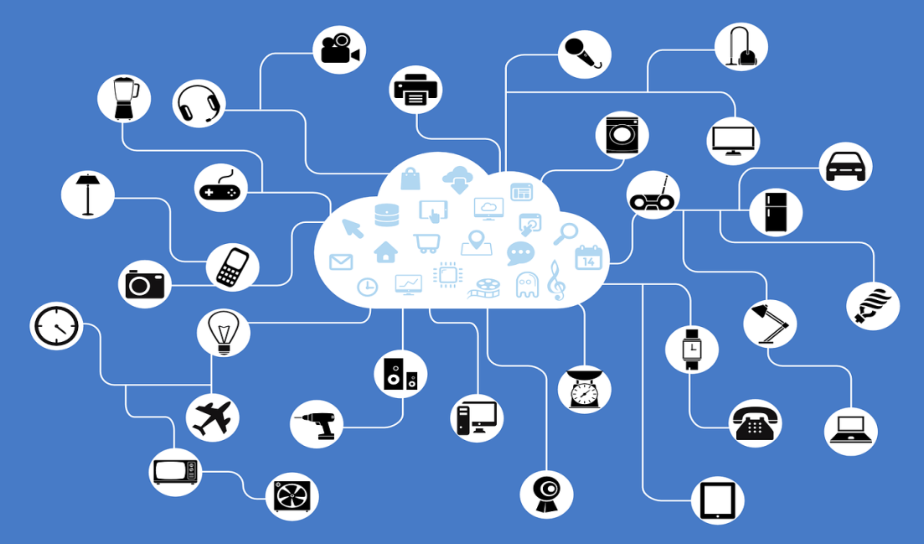

Figure 1 iot connectivity

How does IoT work?

An IoT ecosystem consists of web-enabled smart devices that use embedded systems, such as processors, sensors and communication hardware, to collect, send and act on data they acquire from their environments. IoTdevicess share the sensor data they collect by connecting to an IoT gateway or other edge device where data is either sent to the cloud to be analyzed or analyzed locally. Sometimes, these devices communicate with other related devices and act on the information they get from one another. The devices do most of the work without human intervention, although people can interact with the devices -- for instance, to set them up, give them instructions or access the data[2].

IoT devices contain sensors and mini-computer processors that act on the data collected by the sensors via machine learning. Essentially, IoT devices are mini computers, connected to the internet, and are vulnerable to malware and hacking.

1.2 What is blynk?

Blynk is a new platform that allows you to quickly build interfaces for controlling and monitoring your hardware projects from your iOS and Android device. After downloading the Blynk app, you can create a project dashboard and arrange buttons, sliders, graphs, and other widgets onto the screen. Using the widgets, you can turn pins on and off or display data from sensors.

Whatever your project is, there are likely hundreds of tutorials that make the hardware part pretty easy, but building the software interface is still difficult. With Blynk, though, the software side is even easier than the hardware. Blynk is perfect for interfacing with simple projects like monitoring the temperature of your fishtank or turning lights on and off remotely. Personally, I’m using it to control RGB LED strips in my living room[1].

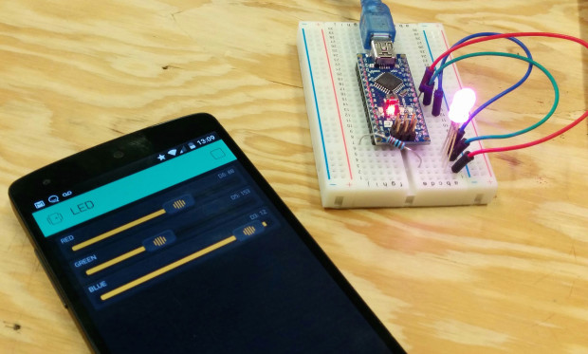

Figure 2 blynk app interface

1.3 OVERVIEW

A load controlled by computer systems has many advantages compared with manual controlled loads. Nowadays there are many programs and applications help to control things better using codes or python algorithms in artificial intelligence projects. In order to save energy and make loads monitored easily, this research suggests smart home project based on IoT technology. This smart home is an Internet of Things (IoT) project that controls loads with internet connection via Wireless Fidelity WIFI connection[1].

A smart phone connected to internet with Blynk application as a control panel, and NodeMCU microcontroller kit in other side as a controller that receives control commands via WIFI signal. NodeMCU kit is built with ESP8266 WIFI receiver that able to process and analyze WIFI signal to input the microcontroller. The WIFI receiver and microcontroller are built in one kit to be used as IoT project. It’s called NodeMCU.

To connect the system to the Internet, needs a WiFi receiver. In our case we used ESP8266 that is connected as built-in in the NodeMCU board that contains a firmware runs with the ESP8266. The firmware is a low-level control computer software. The NodeMCU is coded via Arduino Integrated Development Environment (IDE) with the Universal Serial Bus port (USB) to tell the NodeMCU what to do.

1.4 How does an IoT based Home Automation System Work?

The concept of Home Automation aims to bring the control of operating your everyday home electrical appliances to the tip of your finger, thus giving user affordable lighting solutions, better energy conservation with optimum use of energy. Apart from just lighting solutions, the concept also further extends to have a overall control over your home security as well as build a centralized home entertainment system and much more. The Internet of Things (or commonly referred to as IoT) based Home Automation system, as the name suggests aims to control all the devices of your smart home through internet protocols or cloud based computing[3].

The IoT based Home Automation system offer a lot of flexibility over the wired systems s it comes with various advantages like ease-of-use, ease-of-installation, avoid complexity of running through wires or loose electrical connections, easy fault detection and triggering and above and all it even offers easy mobility.

Home automation works on three levels:

Monitoring: Monitoring means that users can check in on their devices remotely through an app. For example, someone could view their live feed from a smart security camera.

Control: Control means that the user can control these devices remotely, like panning a security camera to see more of a living space.

Automation: Finally, automation means setting up devices to trigger one another, like having a smart siren go off whenever an armed security camera detects motion.

CHAPTER 2

METHODOLOGY

2.1 The Flow of the System

The system is based on NodeMCU board as an internet of things system. The NodeMCU is connected to the internet from the hotspot of the smart phone via WIFI connection as the NodeMCU has ESP8266 circuit to connect with the internet.

NodeMCU to be connected to the hotspot of the smart phone, needs to be identified to the name of hotspot, the password and token code letting the server of Blynk connects them together. You may need the computer once to transfer code from Arduino IDE to the NodeMCU kit to prepare the software part of the project.

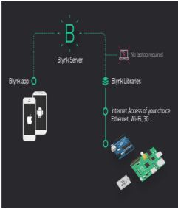

Figure 3 work flow of system

Figure 3 shows that the server of Blynk application will process the smartphone-NodeMCU connection. Blynk libraries are ZIP files can be downloaded from Github website to be imported to the Arduino IDE library. Blynk server will check for internet connection, NodeMCU with android hotspot, the NodeMCU code includes the token code, the name of hotspot and its password.

The information included to the code must be match with the hotspot information to allow ESP8266 connect with the WIFI to be as a channel to exchange commands between smart phone and NodeMCU.

Remaining processes are just commands sent from Blynk application to NodeMCU to control loads those are connected to the relay kit and sensor output value is sent reverse to the Blynk application from NodeMCU kit.

2.1.1 Flow chart of the system

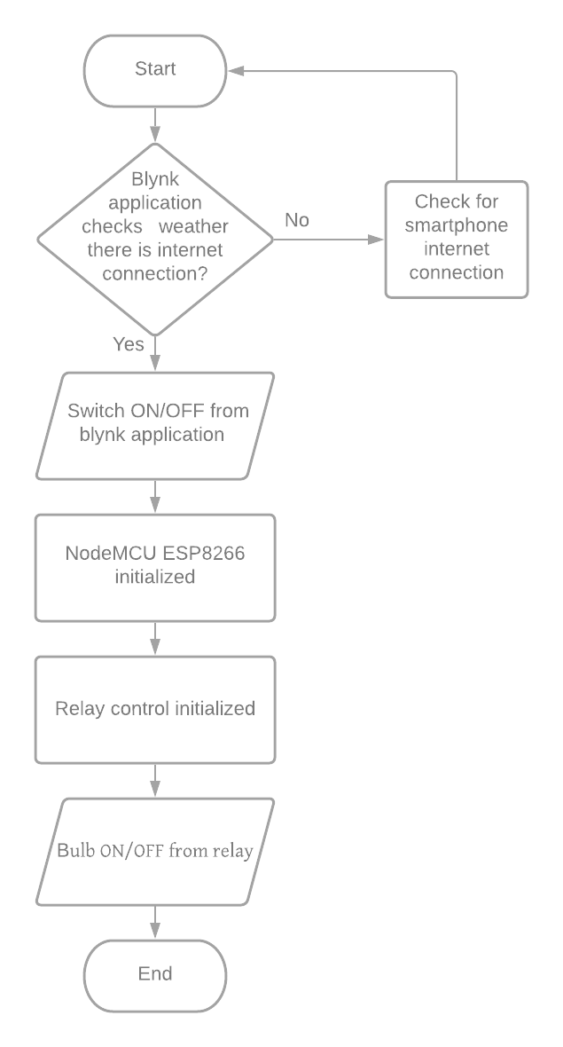

Figure 4 flow chart of system

2.2NodeMCU Code via Arduino IDE

To code NodeMCU via Arduino IDE, the NodeMCU needs to be added to Arduino IDE library first by adding this address to Arduino IDE preferences. After this reference is added to Arduino IDE, download nodeMCU to boards manager and then select NodeMCU 1.0 (ESP12E Module). After nodeMCU is added to Arduino IDE library, upload this code with changing hotspot name and password also token code.Shown in figure 2.2.1.

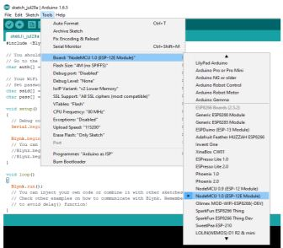

Figure 5 installing nodemcu code in arduino ide

Figure 2.2.2 shows the NodeMCU code. The code includes the hotspot name and password match with the android. The code does not need to identify the relay input, as it is included in 8 [Blynk.run();]. When auth (autho token) is given by Blynk application sent as email and SSID is the name of smart phone hotspot.

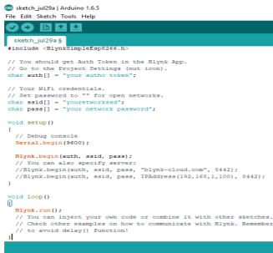

Figure 6 arduino ui with code

CHAPTER 3

HARDWARE AND SOFTWARE REQUIREMENT

3.1 Hardware Requirement

* NodeMCU
* Relay
* Bread Board
* Jump wire

As mentioned above, components used to build the circuit, NodeMCU needs 5VDC as a supply voltage Vin pin, AC-DC step down converter 12V and DC-DC step down converter 5V, in case using AC-DC step down converter 5V, no need to use DC-DC converter. Output voltage of the power supply is connected to VinNodeMCU, Vcc of relay kit

3.1.1 NodeMCU

NODEMCU (esp8266) has been selected as the controller for this system due to its compact size, compatibility, easy interfacing over several other type of controller including Programmable Integrated Circuit (PIC), Programmable Logic Controller (PLC) and others. ESP8266 is an open source firmware that is built on top of the chip manufacturer's proprietary SDK. The firmware provides a simple programming environment, which is a very simple and fast scripting language The ESP8266 chip incorporates on a standard circuit board. The board has a built-in USB port that is already wired up with the chip, a hardware reset button, Wi-Fi antenna, LED lights, and standard-sized GPIO (General Purpose Input Output) pins that can plug into a bread board..Figure-3 shows the diagram of NODEMCU (ESP8266).It has Processor called L106 32bit RISC microprocessor core based on the TensilicaXtensa Diamond Standard 106Micro running at 80 MHz and has a memory of 32 Kbit instruction RAM ,32 Kbit instruction cache RAM, 80 Kbit user data RAM&16 KbitETS system data RAM. It has inbuilt Wi-Fi module of IEEE 802.11 b/g/n Wi-Fi.

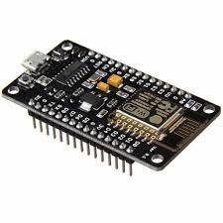

Figure 7 nodemcu esp8266

3.1.2 Pinconfiguration

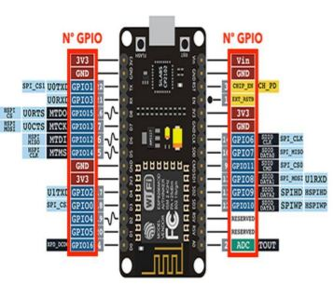

Figure 8 nodemcu pin configuration

**FUNCTIONS**

|  |  |
| --- | --- |
| A0 | A0 is a function (analogRead()) is used to read external voltage applied on ADC pin of module. ESP.getVcc() This function is used to read NodeMCU module VCC voltage. ADC pin must be kept unconnected. |
| G | Power Supply ground. |
| S3 | S0 to S3: Data lines (Quad-I/O mode). |
| S2 | S0 to S3: Data lines (Quad-I/O mode). |
| S1 | S0 to S3: Data lines (Quad-I/O mode). |
| SC | SC: SPI Chip Select. |
| SK | Serial Clock. |
| 3V | 3 volts power supply. |
| EN | Chip enable pin. |
| RST | Reset the chip. |

**GPIO pins**

|  |  |  |
| --- | --- | --- |
| D0 | GPIO16 | It is a general purpose I/O pin used as GPIO read/write; no special functions are supported on it. |
| D1 | GPIO5 | 9 general purpose I/O pins |
| D2 | GPIO4 |
| D3 | GPIO0 |
| D4 | GPIO2 |
| D5 | GPIO14 |
| D6 | GPIO12 |
| D7 | GPIO13 |
| D8 | GPIO15 |
| D9/RX | GPIO1 | RX and TX in order to communicate with a host PC from which compiled object code is downloaded.( 2 pins) |
| D10/TX | GPIO1 |  |
| D11/SD2 | GPIO9 | Not mostly used |
| D12/SD3 | GPIO10 | It is used to respond for GPIO/PWM/interrupt like functions. |

3.1.3 Relay

Relay is nothing but it is the electromagnetic switch. Relay allows one circuit to switch another circuit while they are separated. Relay is used when we want to use a low voltage circuit to turn ON and OFF the device which required high voltage for its operation.

For example, 5V supply connected to the relay is sufficient to drive the bulb operated on 230V AC mains. Relays are available in various configurations of operating voltages like 6V, 9V, 12V, 24V and so on.

Relay is divided into two parts –

One is input and other is output. Input side is nothing but a coil which generate magnetic field when small input voltage is given to it. Relay having three contactors: Normally closed (NC), Normally opened (NO) and common (COM). By using the proper combinations of the contactors electrical appliances may turn ON or OFF.

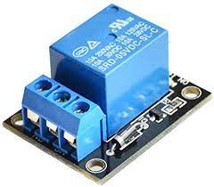

Figure 9 relay module

3.1.4 Breadboard

A breadboard is a rectangular plastic board with a bunch of tiny holes in it. These holes let you easily insert electronic components to prototype (meaning to build and test an early version of) an electronic circuit, like this one with a battery, switch, resistor, and an LED (light-emitting diode).

The connections are not permanent, so it is easy to *remove* a component if you make a mistake, or just start over and do a new project. This makes breadboards great for beginners who are new to electronics. You can use breadboards to make all sorts of fun electronics projects, from different types of robots or an electronic drum set, to an electronic rain detector to help conserve water in a garden

3.1.5 There are different types of breadboards.

Modern breadboards are made from plastic, and come in all shapes, sizes, and even different colors. While larger and smaller sizes are available, the most common sizes you will probably see are "full-size," "half-size," and "mini" breadboards. Most breadboards also come with tabs and notches on the sides that allow you to snap multiple boards together. However, a single half-sized breadboard is sufficient for many beginner-level projects.

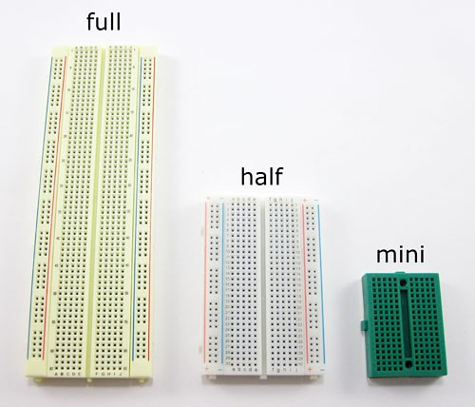

Figure 10 different types of breadbord

3.1.6 WiFi Module

Expressive Systems Smart Connectivity Platform (ESCP) of high performance wireless SOCs, for mobile platform designers, provides unsurpassed ability to embed Wi-Fi capabilities within other systems, at the lowest cost with the greatest functionality.

3.1.7 Jump wire

A jump wire (also known as jumper, jumper wire, jumper cable, DuPont wire or cable) is an electrical wire, or group of them in a cable, with a connector or pin at each end (or sometimes without them – simply "tinned"), which is normally used to interconnect the components of a breadboard or other prototype or test circuit, internally or with other equipment or components, without soldering.

Individual jump wires are fitted by inserting their "end connectors" into the slots provided in a breadboard, the header connector of a circuit board, or a piece of test equipment

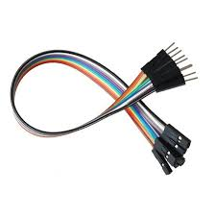

Figure 11 jump wire

3.2 Software requirement

Software requirement for developers

* **Arduino IDE**
* **Blynk App**

Software requirement for user

* **Blynk app**

3.2.1 Arduino IDE

The Arduino Integrated Development Environment (IDE) is a cross-platform application (for Windows, macOS, Linux) that is written in functions from C and C++  It is used to write and upload programs to Arduino compatible boards, but also, with the help of third-party cores, other vendor development boards

The source code for the IDE is released under the GNU General Public License, version 2.

The Arduino IDE supports the languages C and C++ using special rules of code structuring. The Arduino IDE supplies a software library from the Wiring project, which provides many common input and output procedures. User-written code only requires two basic functions, for starting the sketch and the main program loop, that are compiled and linked with a program stub main() into an executable cyclic executive program with the GNU toolchain, also included with the IDE distribution. The Arduino IDE employs the program *avrdude* to convert the executable code into a text file in hexadecimal encoding that is loaded into the Arduino board by a loader program in the board's firmware. By default, avrdude is used as the uploading tool to flash the user code onto official Arduino boards

*Arduuino IDE is only required to developers side not to the user.*

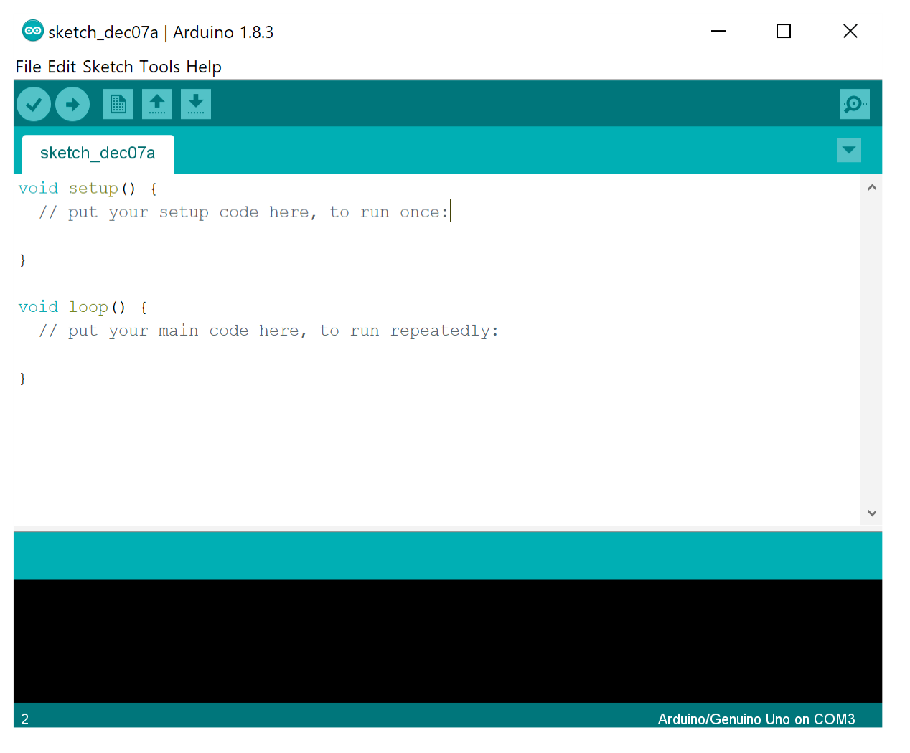

Figure 12 arduino ide

3.2.2 Blynk App

Blynk allows you to create one or moreiot basedprojects.Each project can contain graphical widgets, like virtual LEDs, buttons, value displays and even a text terminal, and can interact with one or more devices. With the help of the Blynk library, it is possible to control Arduino or ESP8266 pins directly from your phone, without having to write any code at all.  
  
It is also possible to share a project with friends and even customers so that they can access the connected devices but not be able to modify the project. Imagine a scenario where you build a smartphone application where you can control lights, window blinds and room temperature from your phone. You can share the project with other family members so that they can also access the functionality.

New version of blynk provide the functionality to access our project from mobile app as well as from website.

Blynk app is required for both i.e. developer as well as user.

In our project we have used “Blynk IOT” version 1.3.7

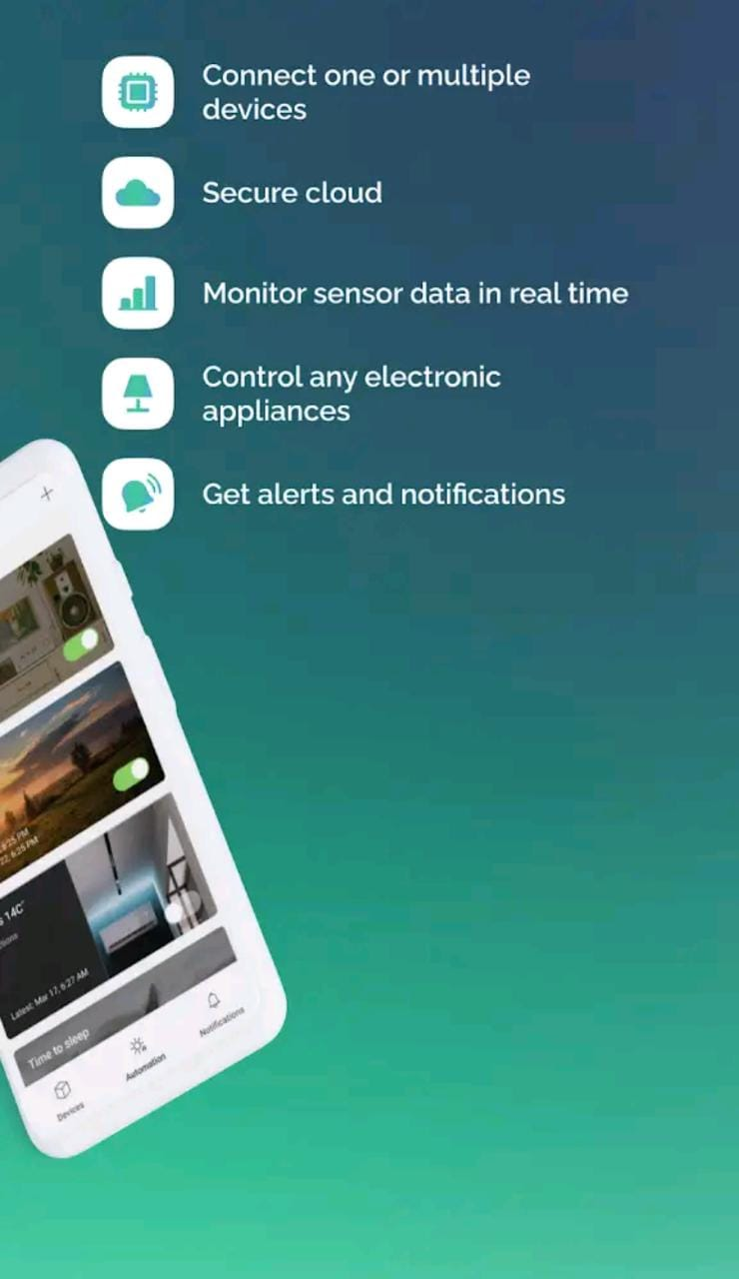 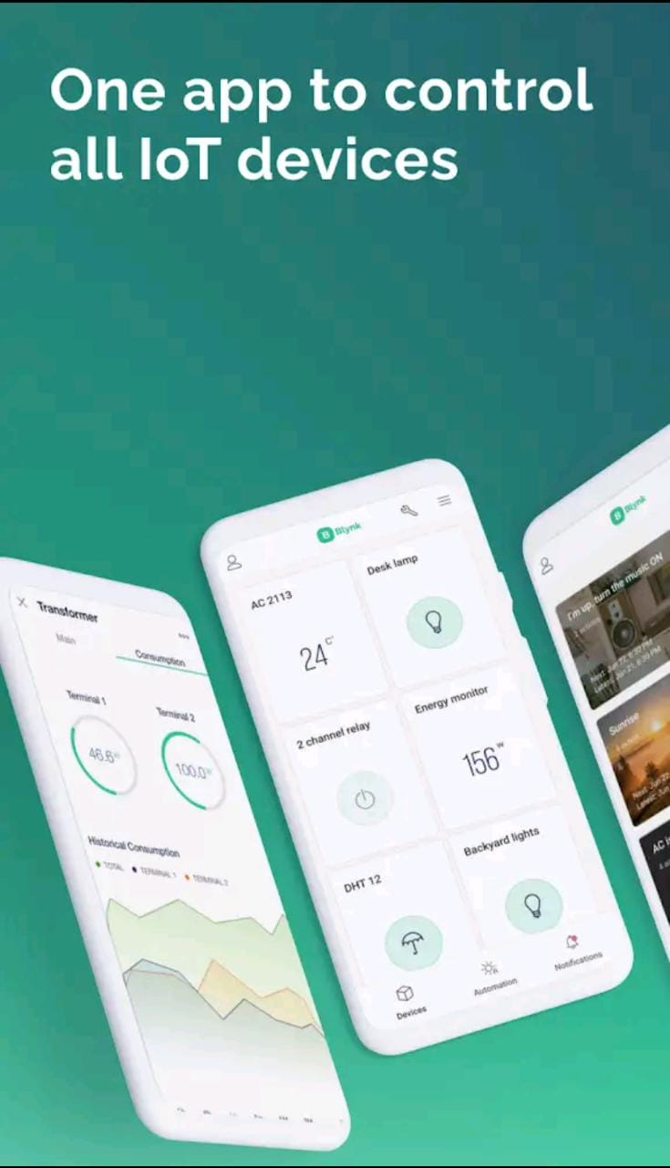

Figure 13 blynk app official picture

CHAPTER 4

OUR PROJECT SNAPSHOTS

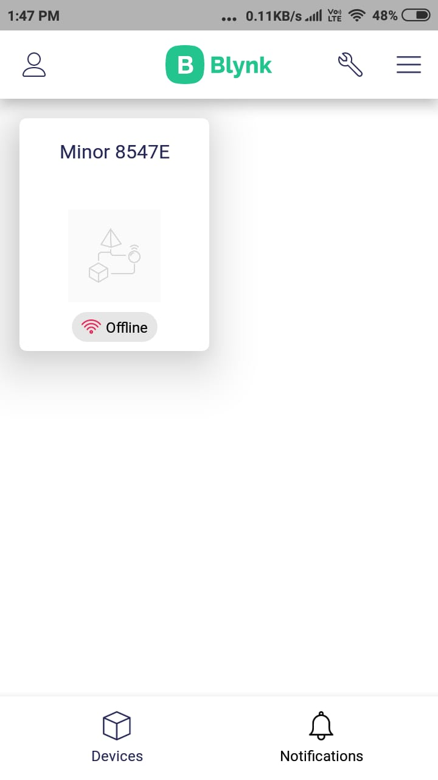

Figure 14 snapshot of blynk interface of our project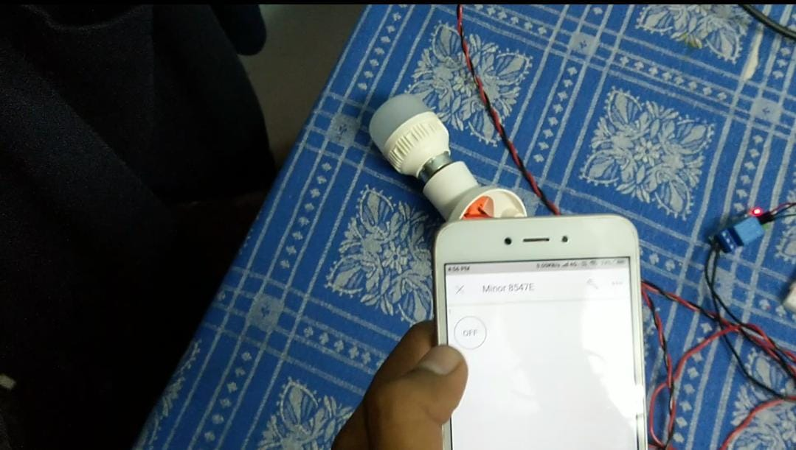

Figure 15 light is turned off when switch is off

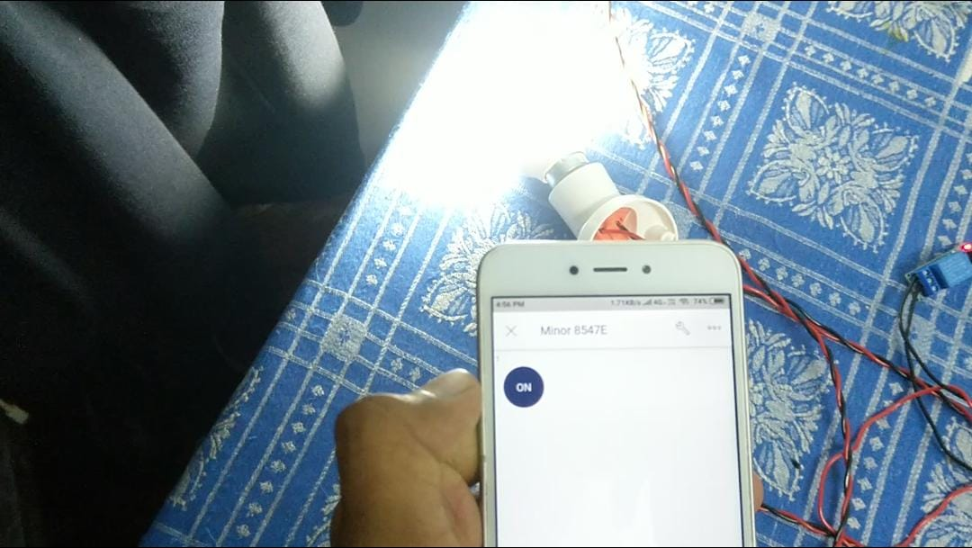

Figure 16 light is turned on when switch is on

CAHPTER 5

RESULT AND DISCUSSION

5.1 Is a Smart Home Worth It?

Yes, certainly a smart home is worth every penny you will spend in the planning, purchase, layout, and installation. If you are not convinced, below we have discussed some of the Major benefits of the standard or custom smart homes.

All the smart appliances can be linked with each other using a single application that will provide you a master control over your house.

Smart products can be controlled from remote areas also. If the smart systems are connected via Bluetooth, you will be able to access them within the defined range only. But if you have chosen the IoT devices, there won’t be any range restriction as IoT technology allows the user to operate the systems from anywhere, provided the system is connected to your mobile over the Wi-Fi network.

It is possible for homeowners to plan custom smart homes as per their need. Be it in terms of the appliances to be included or the type of smart CCTV cameras and door security, you will have independence of choosing them as per your need.

Needless to say, a smart home is obviously much safer as compared to a normal residence. As the security systems are directly integrated with an alert system and your phone, no physical intrusion is possible.

Another Major benefit of the future smart homes is that they will reduce the energy consumption. Even if you forget to switch off the appliances before leaving the house, you can do the same from your phone since the system will be connected to your device over the Wi-Fi. Hence, there will be no wastage of electricity.

5.2 Smart Home Products

In recent years, several smart home products have been introduced to the market that you can definitely get for your residence. Below we have compiled a list of the products that can be operated remotely.

* Smart security systems
* Smart CCTV camera systems
* Smart ceiling fans and LED bulbs
* Smart air conditioners
* Smart alarm systems
* Smart refrigerators
* Smart door and window lock

5.3 Advantages

5.3.1 Save Energy with Smart Energy Consumption:

Energy saving is probably the primary concern for every house owner. With convenient appliances and so many electronic gadgets, the amount of energy consumption is greatly increased. Hence, you would always want to make sure that there is no amount of energy wastage and your home needs to fulfill the need of energy efficiency.

With smart home products, you can ensure that there is no waste of energy usage. The machines, devices and appliances can all be managed and turned off immediately after usage, when you have a smart home product.

Not just this, controlling the lighting of your house will be a lot easier. Since lighting wastes the maximum amount of energy, you can save a lot with the smart appliances. This is a great advantage of this facility.

If you are not in a room or have left a room thinking that you would come back and hence, kept the light bulb or fans turned on or if you simply forgot to turn the lights off, you can benefit hugely with the smart home system it will help you to increase energy savings.

In the flats in Calicut, you would often require the air-conditioners or the fans or the air coolers to be turned on. With the smart home technology, you can turn them off when you are not using them even from your phone.

Solar power for smart houses has brought a big relief for energy consumption these days also for bills. And if your home is not smart enough, no need to worry, take a look at how to make your apartments energy-efficient

5.3.2 Customize as Per Your Convenience:

It is very convenient with smart home automation systems to customize the appliances and smart devices in your home as per your needs. When you want to increase the temperature of your heating system or want to decrease the temperature in your air conditioner, or if you want to turn the water heater on before you reach home or want to turn off everything while lying in the bed, you can do them with just a click on your mobile phone. These features are completely different than our traditional homes.

5.3.3 Ease of using smart home technology:

Along with all these facilities and benefits, another important smart technology advantage is the ease of using this. You can control all these things, without any trouble or difficulty. You can easily manage these things. Even if you are not a very tech savvy person, you will be able to understand how these things work very easily, with some following of the manuals.

With smart home tech you can feel connected home 24/7 even if you are not at home. Here are some important future home technologies you should know about

5.3.4 Smart home technologies are really Smart:

Smart homes are the new and the in thing with Artificial Intelligence. If you want to upgrade yourself and your house according to the global standards and want to become a smart homeowner, then smart system setup is what you can do to your house. Initial cost of setup is a little high but when you look into the long run you save a lot of money with the energy transition process only.

With the help of smart home devices such as smart security cameras, you will be able to take care of the security of your home. Even when you are not at home, you can lock the door of your house.

If someone has reached your home and you haven’t reached yet, you can open the door for him or her with the help of smart cameras & security password and your friend or family member can wait inside. You can have motion detectors in your doors, gates and garage which can be open through one click of a smart phone.

**5.4 Result**

The Light Control Test is done by pressing the ON / OFF button widget on the Blynk application on the respective Android smart phone for lights and fans. This is done after the system is turned on and connected to a Wi-Fi internet connection. If at any time the internet connection is lost or bad signal, then it also affects system performance

Therefore, we can control our electrical home appliances through the Blynk Application

Below table shows the test result performed by blynk app

|  |  |  |
| --- | --- | --- |
| **Switch Status** | **ON** | **OFF** |
| On | Realy1 | ------ |
| OFF | ----- | Relay1 |

CHAPTER 6

CONCLUSION

**Conclusion:**

It is evident from this project work that an individual control home automation system can be cheaply made from low-cost locally available components and can be used to control multifarious home appliances ranging from the security lamps, the television to the air conditioning system and even the entire house lighting system. And better still, the components required are so small and few that they can be packaged into a small inconspicuous container. The designed home automation system was tested a number of times and certified to control different home appliances used in the lighting system, air conditioning system, home entertainment system and many more . Hence, this system is scalable and flexible.

CHAPTER 7

REFERENCES and BIBLIOGRAPHY

References

* BOHORA, Bharat; MAHARJAN, Sunil; SHRESTHA, Bibek Raj. IoT Based Smart Home Using Blynk Framework. Zerone Scholar, [S.l.], v. 1, n. 1, p. 26-30, dec. 2016. ISSN 2542- 2774. google scholar.
* <http://zerone.pcampus.edu.np/ojs/index.php/scholar/article/view/6/5>
* A Review Paper on Home Automation
* An Intelligent, Secure and Smart Home Automation System
* Home Automation Systems